// Assignment no-3(1)

// Name- Prerana Rajesh Gajare Class-SEIT RollNo-SI41

/\*PROBLEM STATEMENT:-

3. Write an Embedded C program to transfer elements from one location to another for following:

i) Internal to internal memory transfer

\*/

//Source Code:-

#include <xc.h>

#include <stdio.h>

#include <stdlib.h>

#include <pic18f4550.h>

void main()

{

int i;

int source1[]= {0x50, 0x80, 0x10, 0x25, 0x60};

int dest[]= {0x00, 0x00, 0x00, 0x00, 0x00};

for(i=0;i<=4;i++)

{

dest[i]=source1[i];

}

TRISD=0;

for(i=0;i<=4;i++)

{

PORTD=dest[i];

/\* for(int n=0;n<1000;n++)

{

for(int j=0;j<500;j++)

{

}

}

\*/

}

return ;

}

\*\*\*\*\*\*\*\*\*\*\*\*\*\*\*\*\*\*\*\*\*\*\*\*\*\*\*\*\*\*\*\*\*\*\*\*\*OUTPUT\*\*\*\*\*\*\*\*\*\*\*\*\*\*\*\*\*\*\*\*\*\*\*\*\*\*\*\*\*\*\*\*\*\*\*\*\*\*

1. I/O VIEW

A] 50

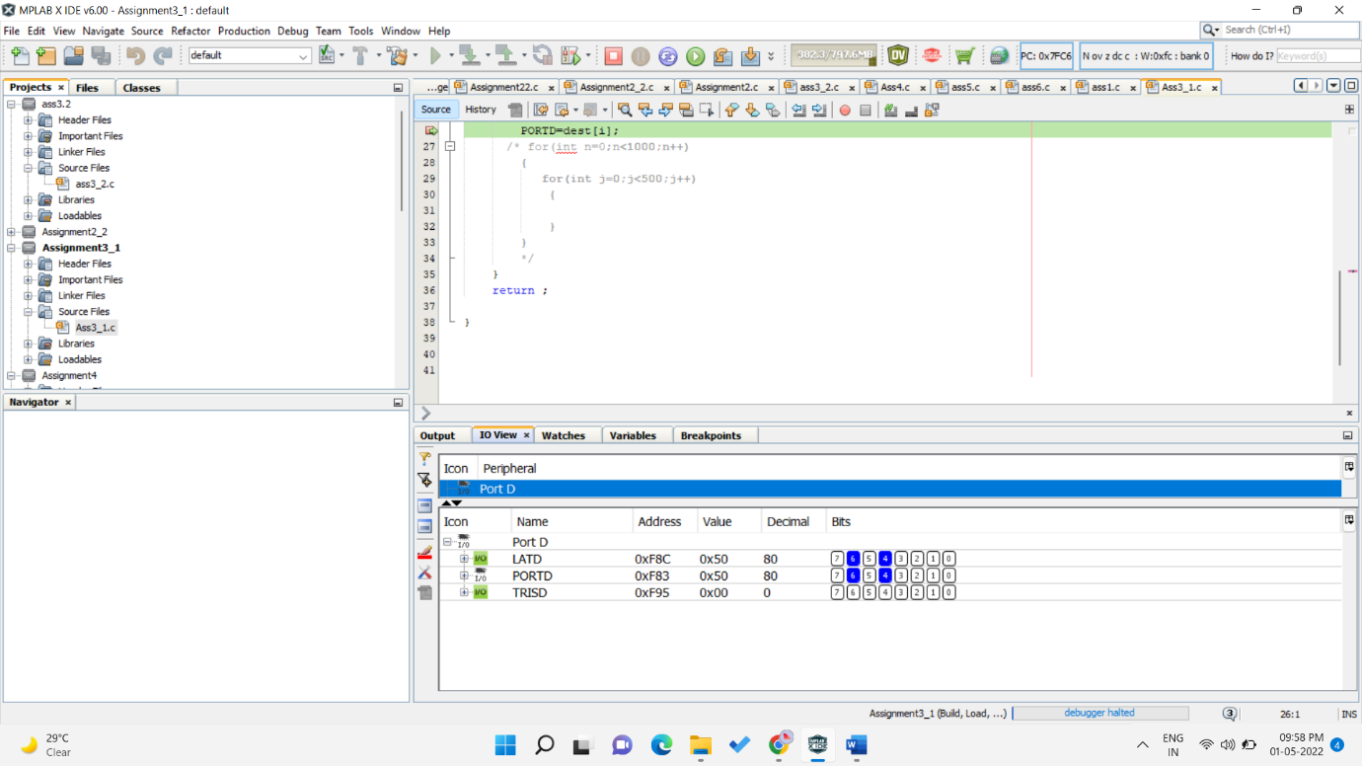

B]80

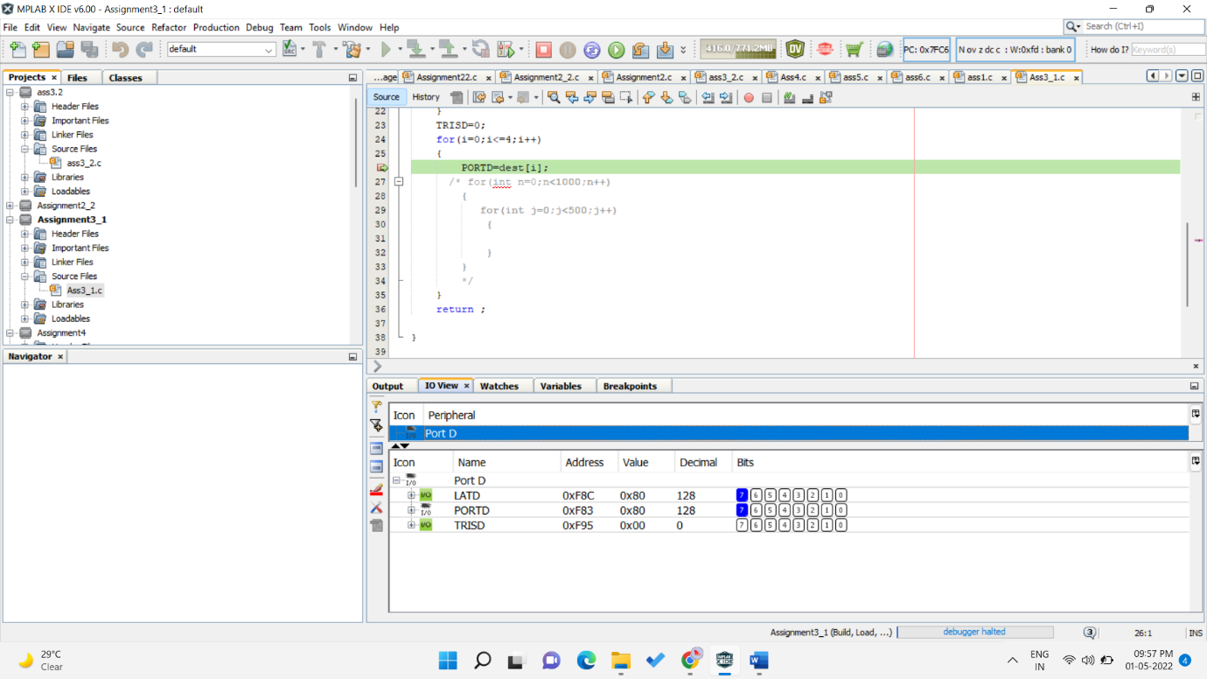

C]10

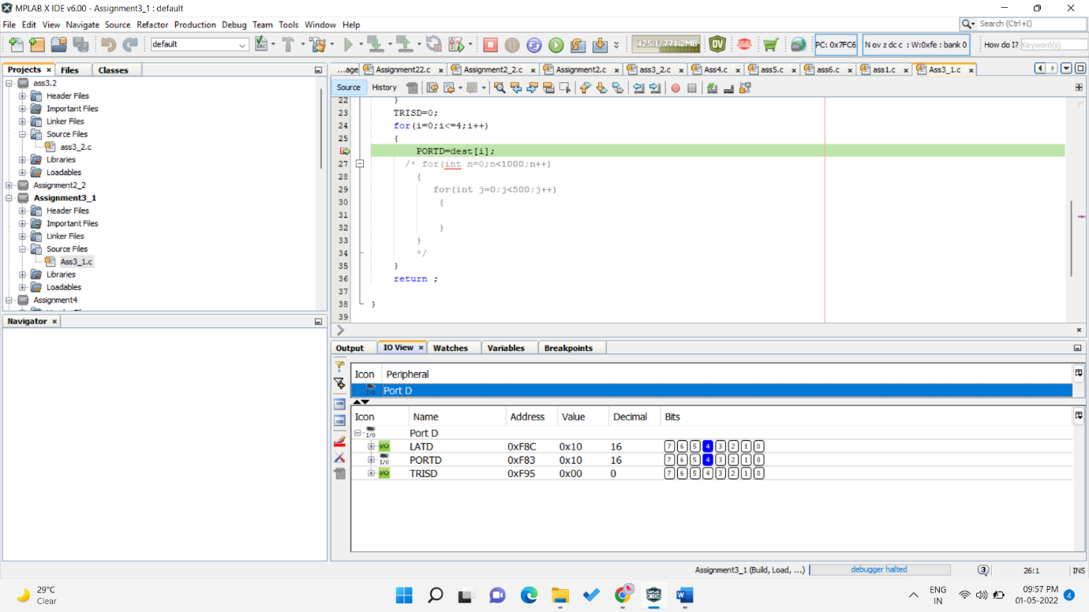

D]25

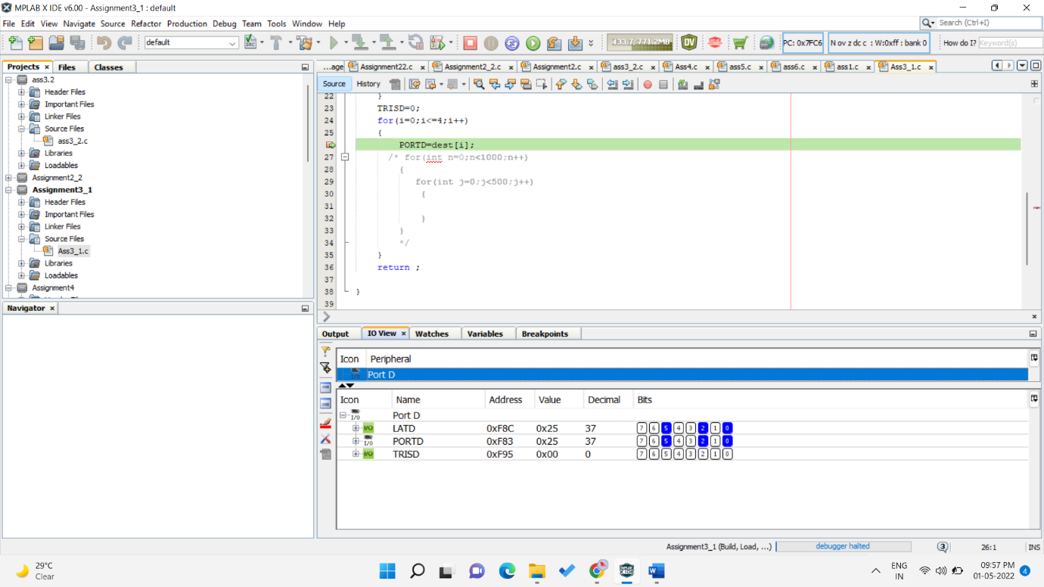

E]60

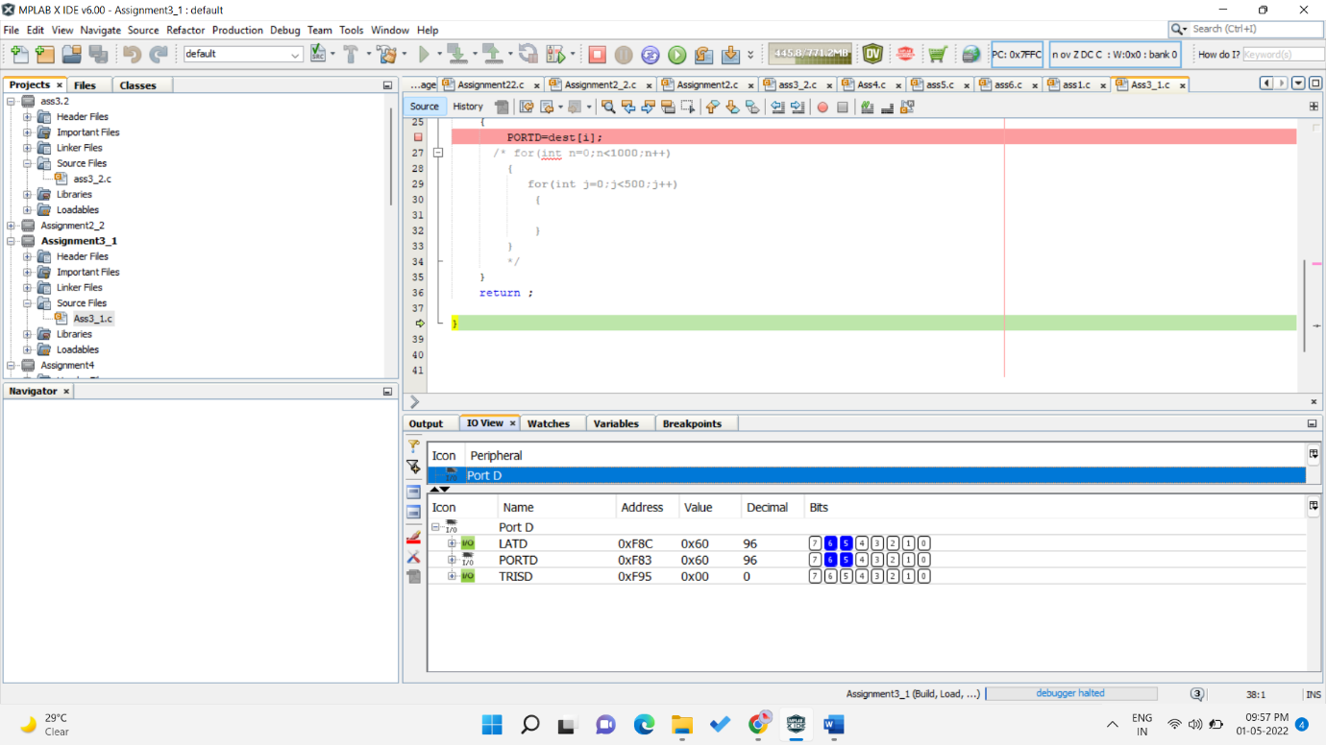

1. PICSIM LAB OUTPUT

A]50

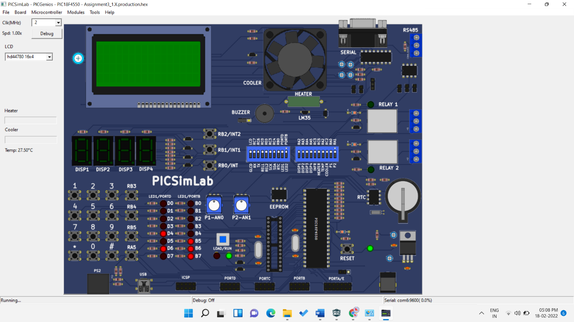

B]80

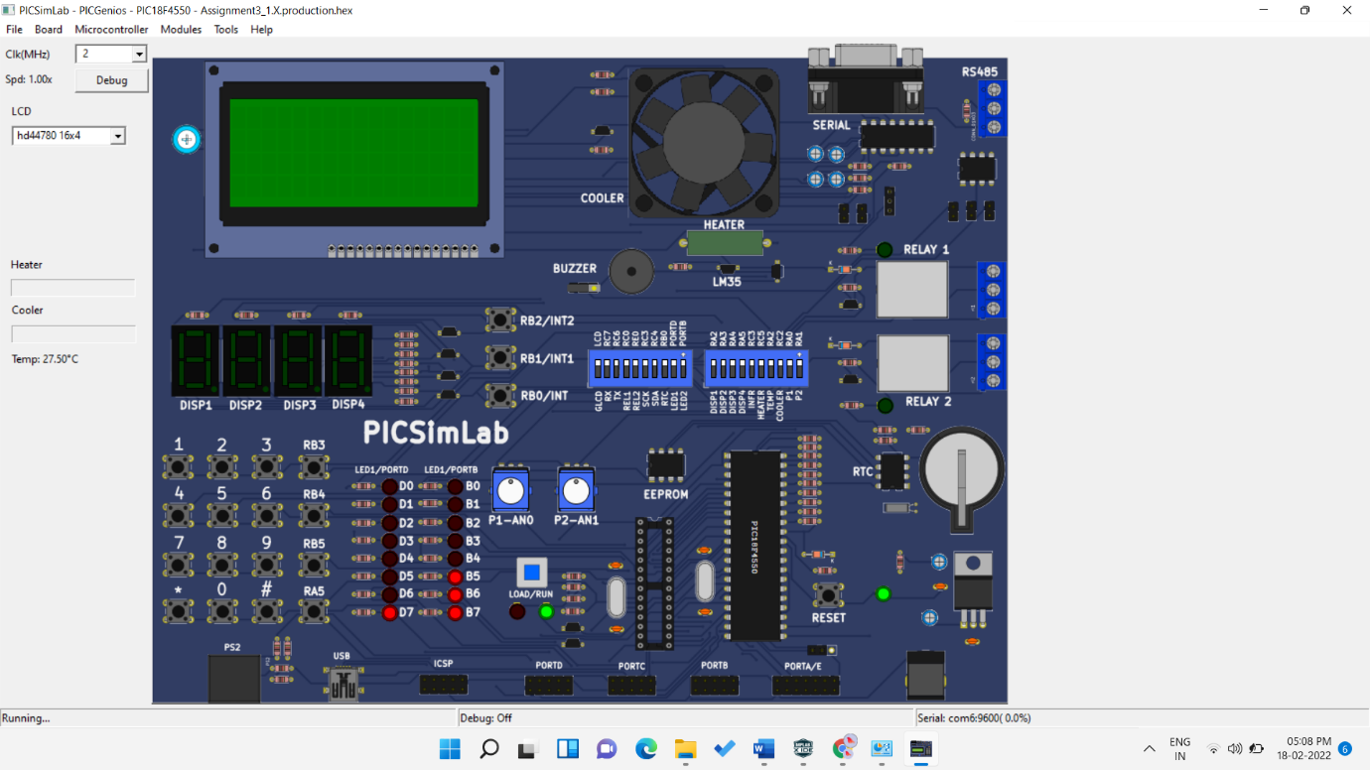

C]10

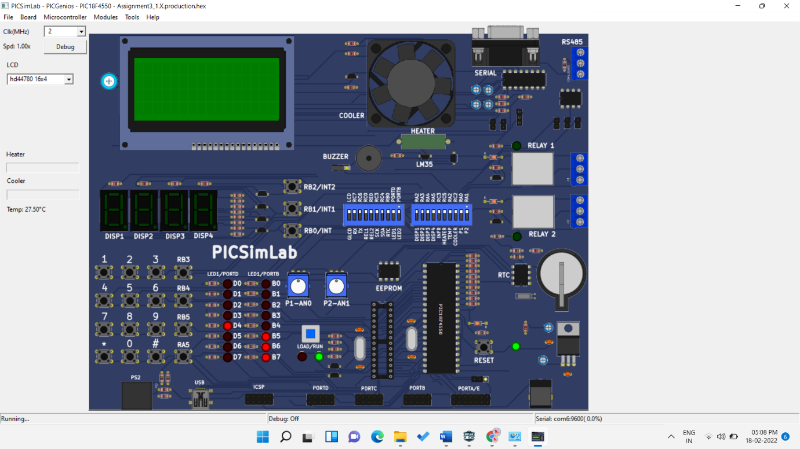

D]25

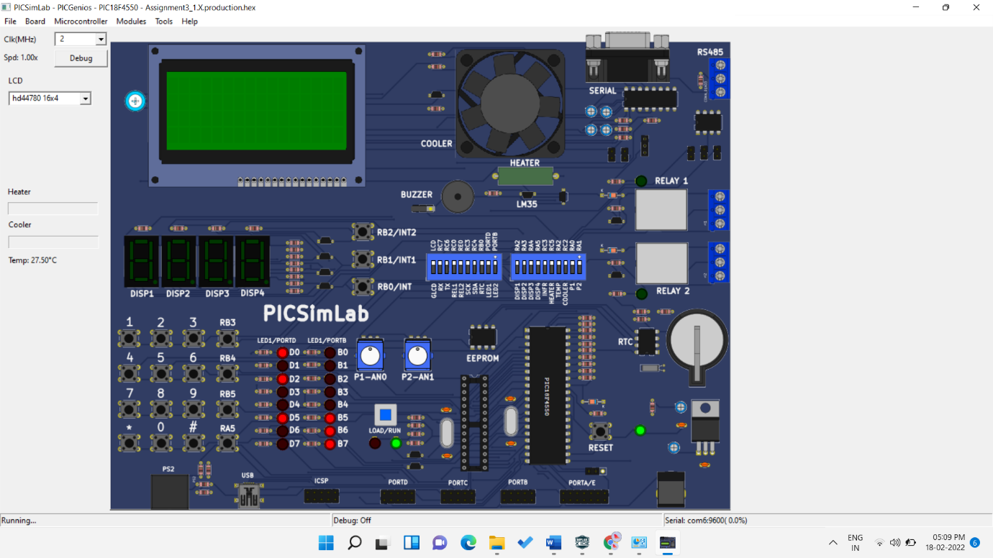

E]60

